Week 6 Task: Reporting and Presentation
Comprehensive Financial Data Analysis Project — Weeks 1–5
Primary data source: World Bank World Development Indicators (WDI)
Project scope: data acquisition → EDA → forecasting → risk analysis → hypothesis testing → visualization → final reporting

1. Executive Summary
This final report consolidates the financial-data work completed across Weeks 1–5. The project began with a 15-country exploration of three World Bank banking-system indicators: bank capital to assets, non-performing loans (NPLs) as a percentage of gross loans, and private-sector credit provided by banks as a percentage of GDP. Week 1 established the data foundation and exploratory analysis. Week 2 extended the work into a basic India NPL forecast using a transparent three-year moving-average baseline. Week 3 translated the indicators into a structured risk register and risk matrix. Week 4 applied hypothesis-testing methods to the India NPL time series. Week 5 focused on communicating financial patterns through ranked charts, scatter plots and a correlation matrix.
The Week 1 sample shows substantial variation in banking-system indicators. Capital-to-assets ranges from 4.07% to 13.73%, NPLs from 0.46% to 5.31%, and private credit from 26.56% to 194.17% of GDP. The analysis demonstrates that financial-system condition cannot be represented by one indicator alone.

2. Project Objectives
- Acquire and prepare publicly available banking and financial-system data.
- Compare banking-system capitalization, asset quality and credit depth across countries.
- Build a simple, reproducible financial forecast.
- Identify and prioritize financial and analytical risks.
- Apply statistical hypothesis testing to a financial time series.
- Use visualizations to communicate comparisons, relationships and trends.
- Produce a coherent final report with findings, limitations and recommendations.

3. Week-by-Week Summary
Week | Work Completed | Main Output
Week 1 | Data acquisition, cleaning, EDA, descriptive statistics, comparisons and correlations | 15-country banking dataset, EDA charts and report
Week 2 | Basic India NPL forecast using a 3-year moving average | Historical/forecast series, forecast chart and report
Week 3 | Risk identification, likelihood-impact assessment and mitigation planning | Risk register, risk matrix and report
Week 4 | Hypothesis testing on the India NPL time series | Hypotheses, Pearson correlation/regression and statistical report
Week 5 | Financial visualization and chart-selection analysis | Ranked bar charts, scatter plots, correlation matrix and report

4. Week 1 — Financial Data and EDA
The project used 15 countries and three indicators. The mean bank capital-to-assets ratio was 8.12% (median 7.75%), the mean NPL ratio was 2.17%, and mean private-sector credit was 84.67% of GDP. The lowest and highest capital-to-assets observations were Japan (4.07%) and Saudi Arabia (13.73%). For NPLs, the lowest and highest were Canada (0.46%) and United Arab Emirates (5.31%). Private credit ranged from Mexico (26.56% of GDP) to China (194.17% of GDP).
Week 1 also found a Pearson correlation of -0.60 between capital-to-assets and private credit, -0.38 between NPLs and private credit, and 0.25 between capital and NPLs. These are exploratory relationships and are affected by differing observation years.

5. Week 2 — Financial Forecasting
India's NPL ratio was selected for a basic forecast because it provides a clear annual financial time series. A three-year moving average was used as a transparent baseline. The resulting model forecasts 4.33% for 2024, 3.61% for 2025 and 3.21% for 2026. These are model outputs, not guarantees. The model is intentionally simple and should be treated as a baseline that can be improved with longer data, macroeconomic variables and alternative time-series methods.
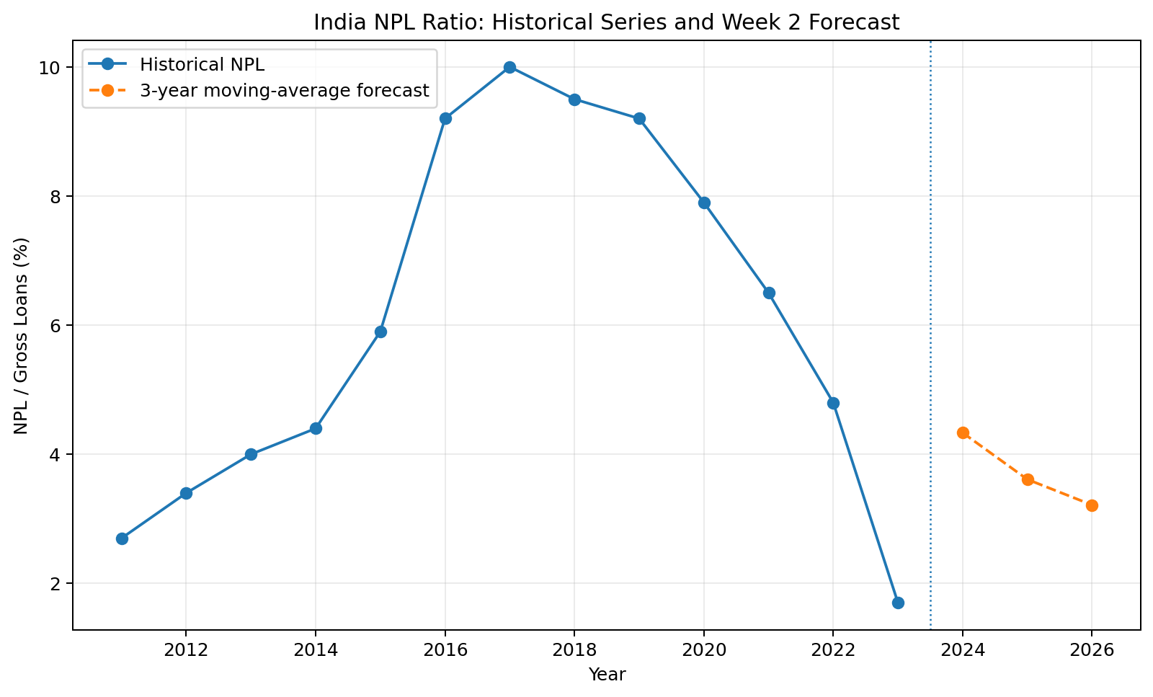

6. Week 3 — Risk Analysis
The risk analysis identified six areas requiring attention: asset-quality deterioration, forecast/model uncertainty, data comparability and timing risk, credit-cycle and concentration risk, capital adequacy pressure, and over-reliance on aggregate indicators. A likelihood-impact framework was used to prioritize risks and attach practical mitigation strategies. The analysis emphasized that NPLs, capital and credit depth should be considered together rather than as isolated measures.

7. Week 4 — Hypothesis Testing
Using the historical series that underpins the Week 2 forecast, the hypothesis-testing question was whether year and India's NPL ratio have a linear association. The Pearson correlation is 0.214 with p = 0.482328, and the regression slope is 0.156 percentage points per year with R² = 0.046. At α = 0.05, the null hypothesis of no linear association is rejected. This demonstrates a statistically detectable negative time trend in the selected sample, but it does not establish causation.

8. Week 5 — Visualization
The visualization work used different chart types for different questions. Horizontal bar charts were used for country rankings, scatter plots for relationships between continuous indicators, and a correlation matrix for a compact summary of linear associations. The key lesson is that effective financial visualization is not simply about producing attractive charts; the chart type and ordering should directly support the analytical question.

9. Integrated Findings
- Financial-system health is multidimensional: capitalization, asset quality and credit depth provide different information.
- Cross-country banking indicators show large differences, but observation-year differences limit direct causal interpretation.
- India is a useful case for time-series analysis because its NPL series changed substantially over the historical period used in the project.
- A simple moving-average forecast provides a transparent baseline, but model uncertainty must be treated as a material risk.
- Statistical significance does not imply causation; time-trend results require economic and institutional context.
- Visualization improves communication when chart selection is aligned with the underlying analytical question.

10. Recommendations for Future Analysis
- Build a synchronized panel using common observation years before making stronger cross-country comparisons.
- Extend the historical India series and compare moving average, exponential smoothing and ARIMA-style approaches.
- Add macroeconomic variables such as GDP growth, inflation, unemployment and interest rates to investigate drivers of NPLs.
- Add banking indicators such as return on assets, provisioning, liquidity and capital adequacy measures.
- Use stress-testing scenarios to evaluate how NPL shocks could affect bank capital.
- Create an interactive dashboard with filters for country, indicator and observation year.
- Use confidence or prediction intervals for forecasts rather than relying only on point estimates.

11. Data Quality and Consistency Note
During final-project consolidation, a data consistency issue was identified: the historical India NPL values stored in the Week 4 analysis file are not identical to the historical values stored in the Week 2 forecast file for several years. Because Week 2's forecast is explicitly based on its historical series, this final report uses the Week 2 historical series when summarizing the forecast and when recomputing the hypothesis test. This prevents the final report from combining incompatible versions of the same time series. Before treating the internship repository as a fully audited production project, the Week 4 source series should be replaced with the Week 2 series and the Week 4 calculations rerun.

12. Limitations
The project is an educational financial-data analysis rather than a regulatory stress test, investment recommendation or bank-level risk model. The Week 1 cross-country sample is intentionally small, and observation years are not synchronized. The Week 2 forecast is a simple baseline. The hypothesis test uses a short annual time series and therefore should be interpreted cautiously. Aggregate indicators also hide differences between individual banks and loan portfolios. These limitations motivate the recommendations for future analysis.

13. Conclusion
Across six weeks, the project developed from raw public financial data into a structured analytical workflow. The work progressed from data acquisition and exploratory analysis to forecasting, risk assessment, statistical testing and visualization. The combined results show why financial analysis benefits from multiple complementary indicators, explicit assumptions, reproducible calculations and careful communication of uncertainty. The next logical step is to strengthen the time-series and cross-country analysis with synchronized data, additional economic drivers, more rigorous forecasting methods and interactive reporting.

14. Reproducibility and Project Structure
The supporting files include the Week 1 dataset and analysis code, Week 2 forecast data/chart/script, Week 3 risk register/matrix/script, Week 4 hypothesis-testing data/chart/script, and Week 5 visualization data/charts/script. The GitHub repository can organize these into Week 1 through Week 6 folders with a top-level README presenting the complete project.

